**Project-Retrieving S3 Archives Using AWS Console**

Tasks:

* Create S3 bucket

* Upload the object

* Retrieve the data

* Cleanup

Task1: Create S3 bucket

In the AWS Console search bar, search for S3

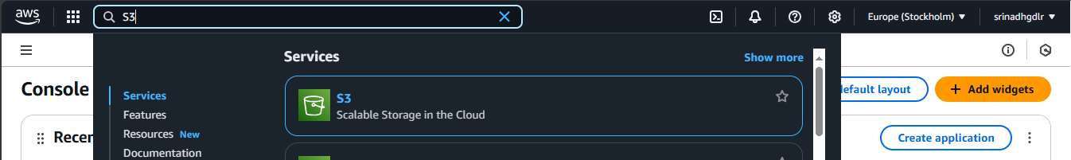

Choose S3 and click on Create bucket button

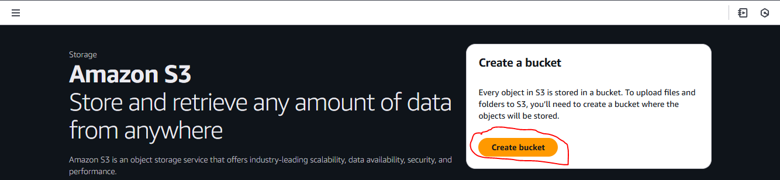

In the Create bucket window, Configure below settings.

-Enter a descriptive globally unique name for your bucket name: retrive-s3-archives1

-The default Block Public Access setting is appropriate for this workload, so leave this section as is.

(Next, enable bucket versioning to protect your data from accidental or malicious user deletes or overwrites.)

-Bucket Versioning: Enable

(Now you have the option to enable S3 Object Lock in the Advanced settings section. With S3 Object Lock, you can store objects using a write-once-read-many (WORM) model. S3 Object Lock can help prevent objects from being deleted or overwritten for a fixed amount of time, or indefinitely. S3 Object Lock can be used to help meet regulatory requirements that require WORM storage, or to simply add another layer of protection against object changes and deletion. For this workload, it is appropriate to enable S3 Object Lock to ensure important archived data is not deleted prematurely by unauthorized users.)

-In the Advanced settings section Choose the Enable option and check the check box to acknowledge enabling the S3 Object Lock settings.

Then, select the Create bucket button.

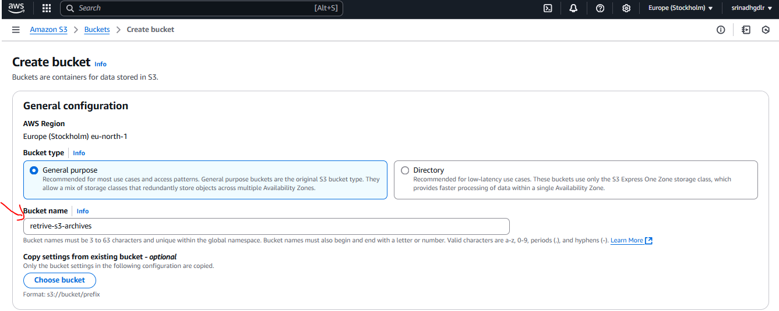

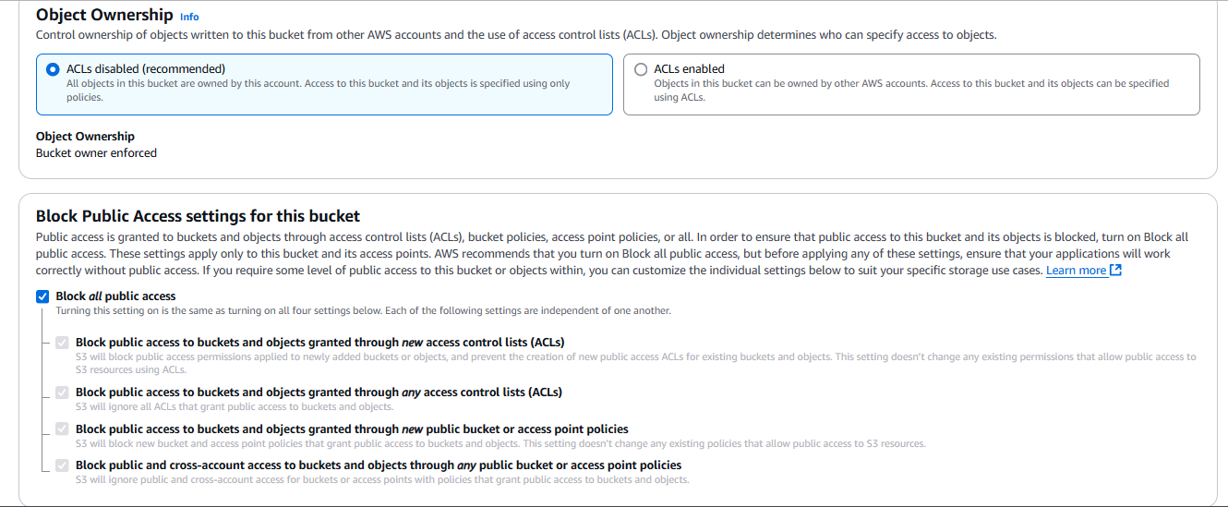

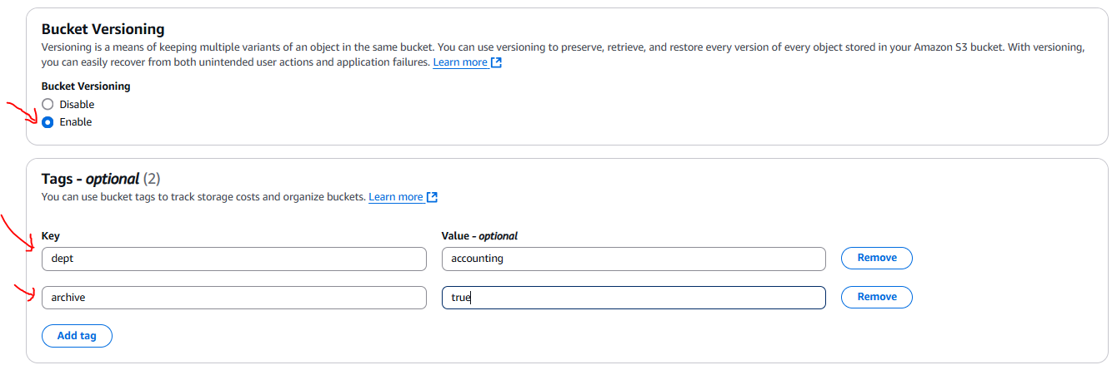

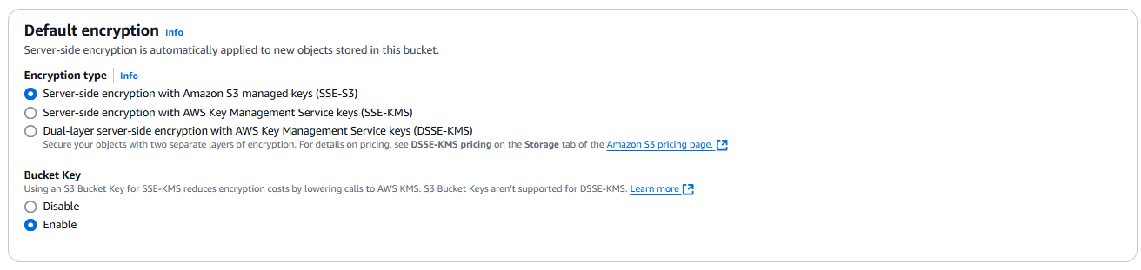

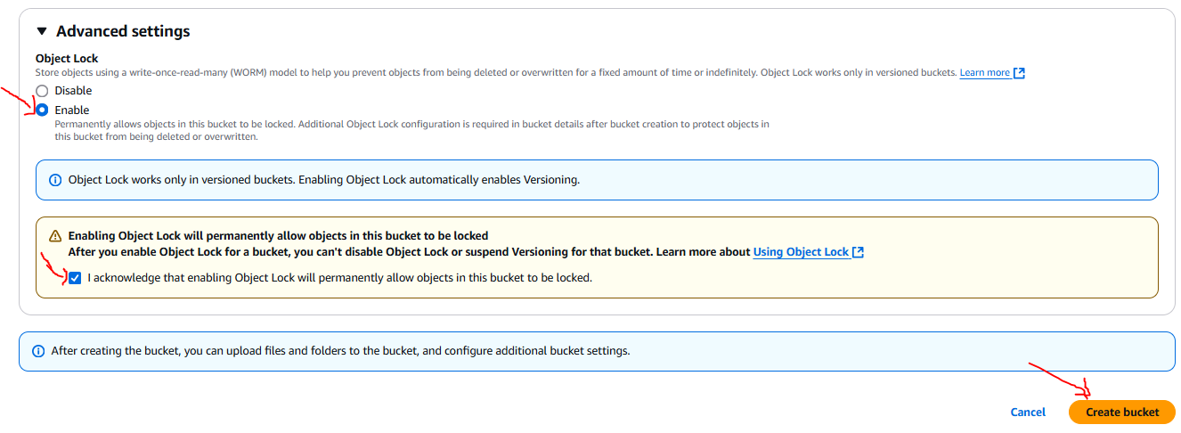

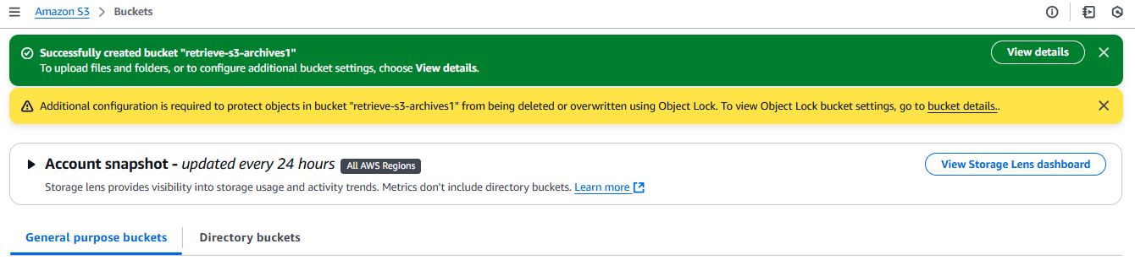

* Next, the S3 console will present a banner indicating the bucket creation was successful. The S3 console will also present a prompt informing you that additional configuration is needed to enable the S3 Object Lock feature. Select the bucket details link presented in the prompt. Making this selection will open the Properties tab for your newly created bucket.

* <Note: For this exercise, use Governance mode for the S3 Object Lock configuration. This will allow you to permanently delete your test object using an admin user after this tutorial has completed.>

Click on the S3 bucket

-On the bucket Properties tab, navigate to the Object Lock section and select the Edit button. Here you can set your default values for objects uploaded to your bucket. For this example, you want to enable retention for all objects uploaded to this bucket for 2 years. Select Enable for the Default retention option, choose governance mode by selecting the Governance option under Default retention mode and enter ‘2’ as the default retention period. Lastly, select Years for the unit of measure and then select the Save changes button.

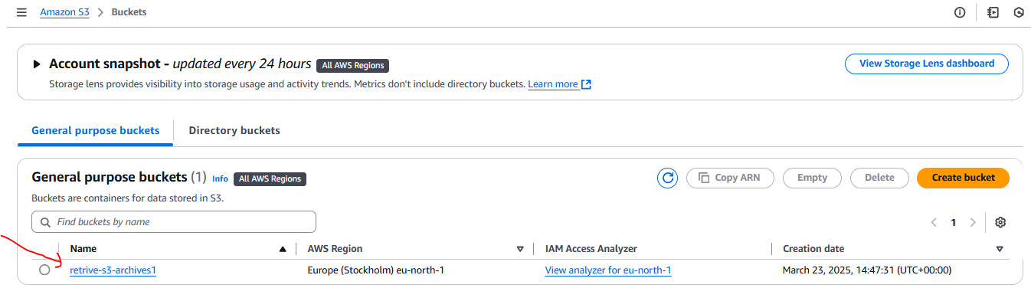

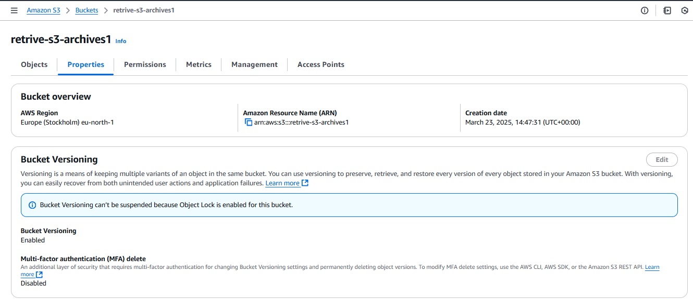

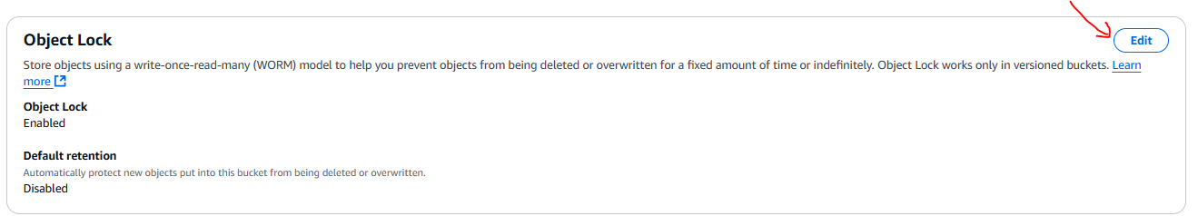

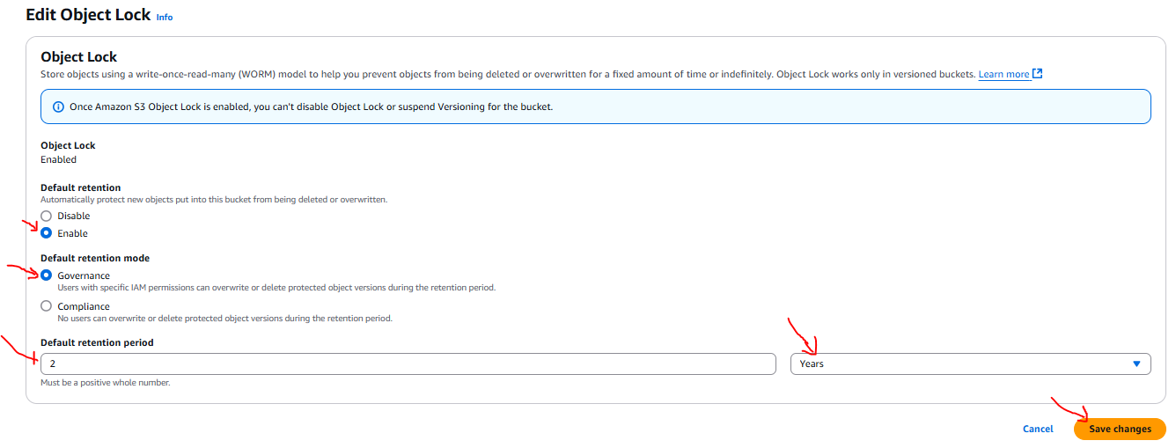

**Task2: Upload the object**

* Now that your bucket has been created and configured, you are ready to upload archive data to the Amazon S3 IA storage classes.

— Object upload

* Navigate to the S3 console, From the list of available buckets, select the bucket name of the bucket retrive-s3-archives1 you just created and click on it.

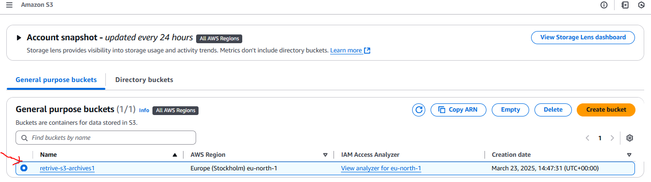

* Next, choose the Objects tab. Then from within the Objects section, select the Upload button.

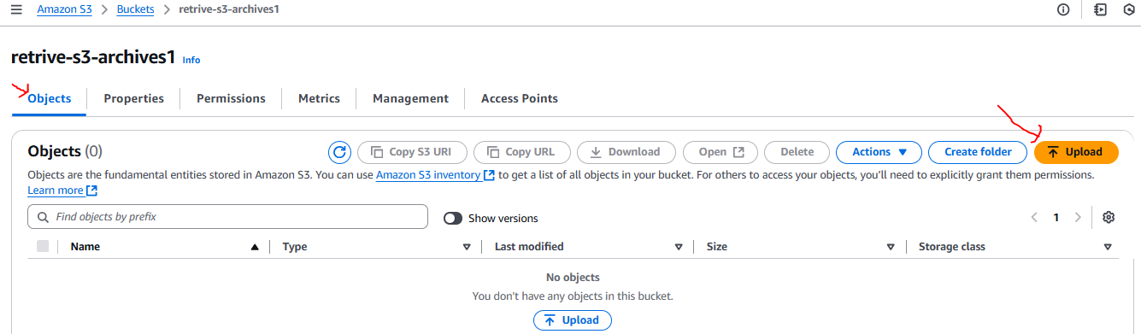

* Then, select the Add files button. Navigate your local file system to locate the archive file you would like to upload. Select the appropriate file and then select Open. Your file will be listed in the Files and folders section.

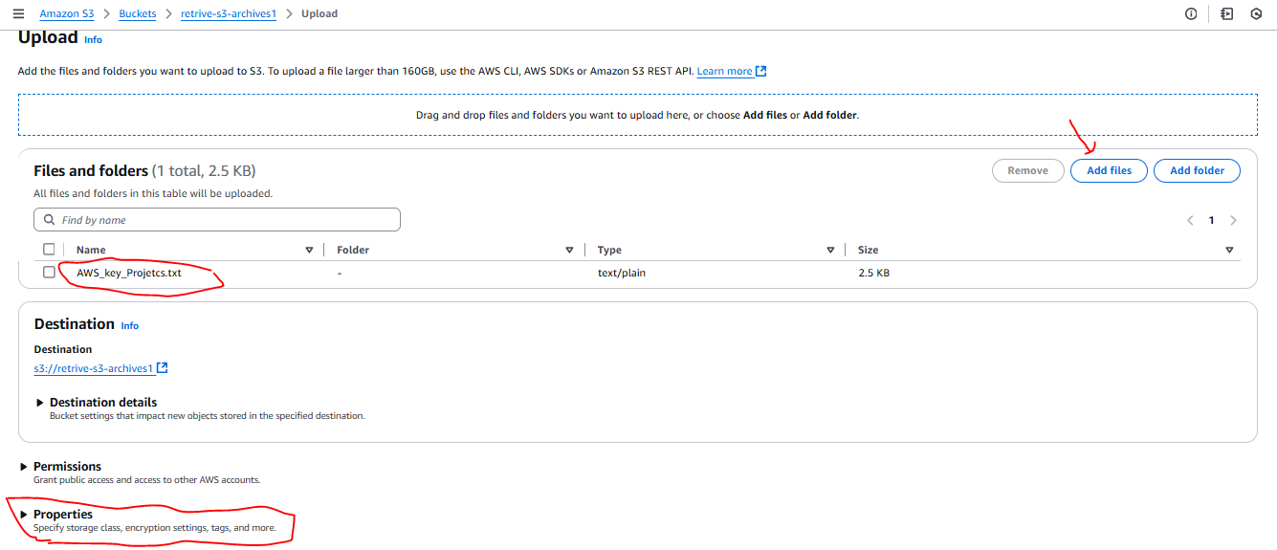

* Expand the Properties section, select the S3 storage class you would like to upload your archive to. Select Standard IA and click on Upload button.

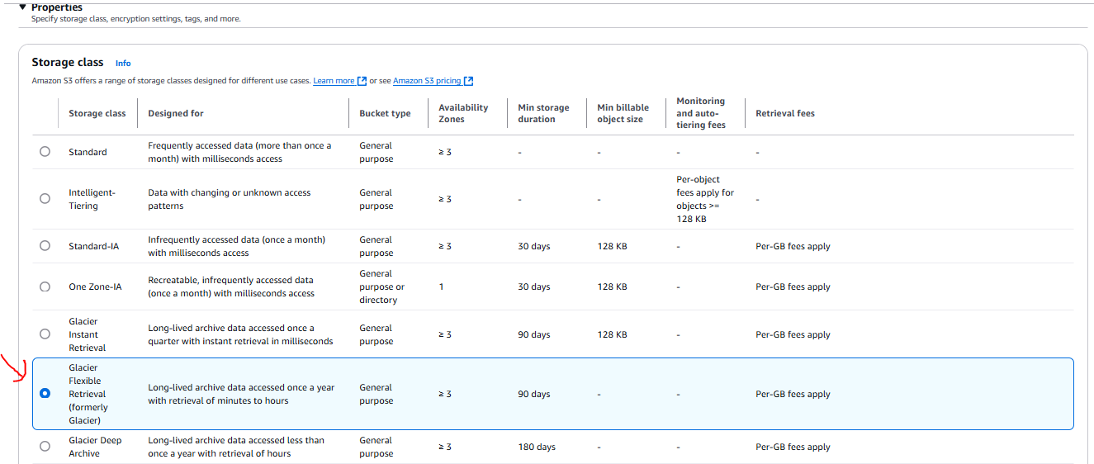

* After your file upload operations have completed, you will be presented with a summary of the operations indicating if it has completed successfully or if it has failed. In this case, the file has uploaded successfully. Select the Close button.

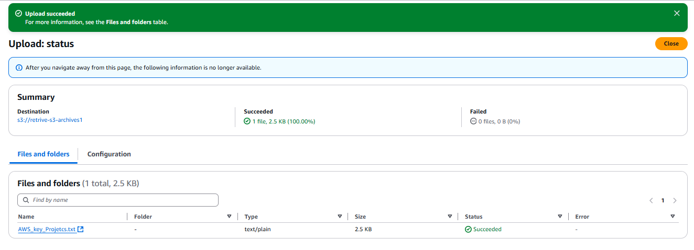

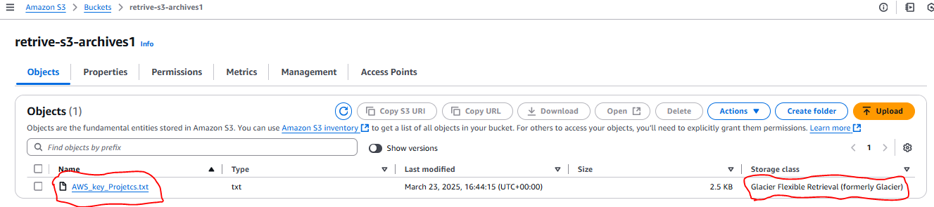

**Task3: Retrieve the data**

Now that you have successfully uploaded your data to Glacier Flexible Retrieval, let’s go over the process of restoring your data.

--**Initiate object restore**

* Navigate to the S3 console, From the list of available buckets, select the bucket name of the bucket you have created. From the Objects menu, select the name of the test file you just uploaded.

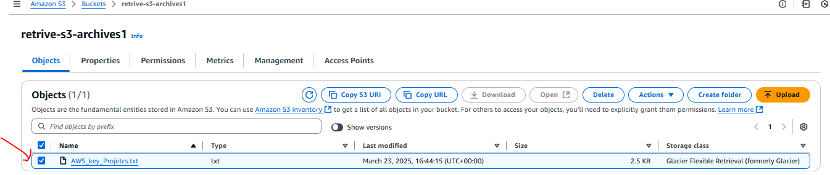

* After selecting your test file’s name, you will be presented with a banner indicating that your object is stored in the Glacier Flexible Retrieval storage class and that you need to restore it if you would like to access your data. You can initiate the restore process by simply selecting the Initiate restore button attached to the information banner, or you can choose Initiate restore from the Object actions menu.

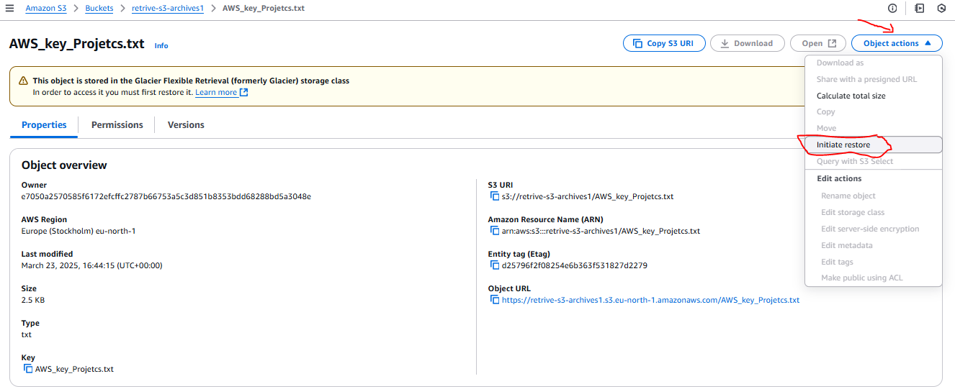

o From the Initiate restore page, you will define the number of days you desire to make your restored copy available. Next, you will have a choice between standard or bulk retrieval. For this exercise, choose the Standard retrieval option. Then, select the Initiate restore button to continue.

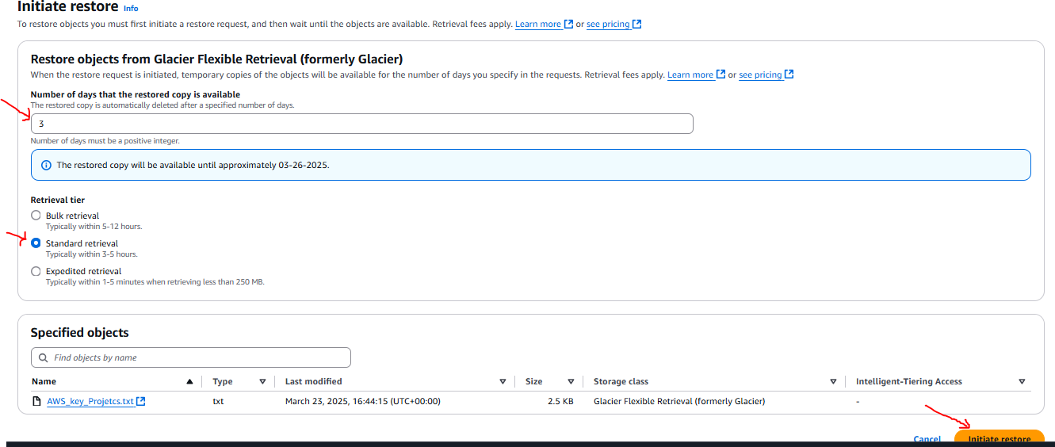

o A summary page will be displayed indicating if the restore request was successful or if any errors occurred. In this case, the restore request was successful. Select the Close button to continue.

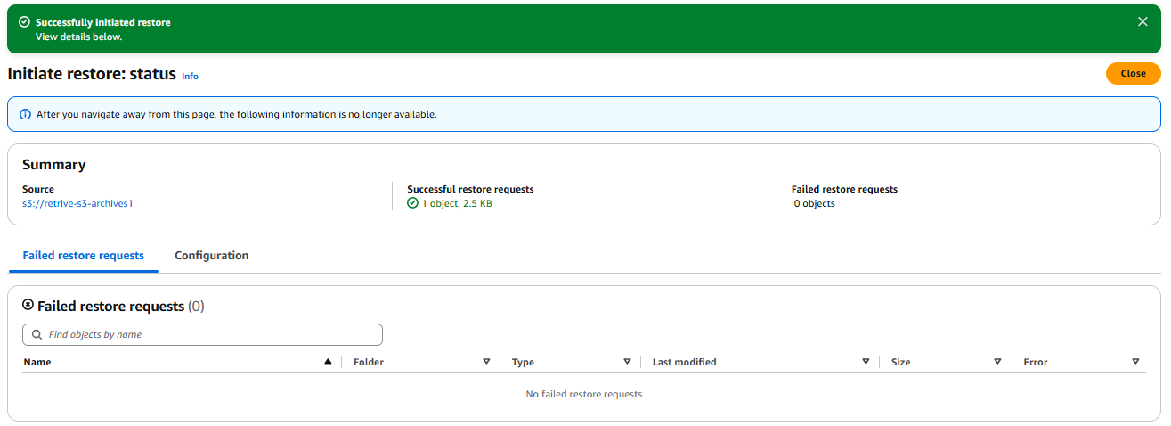

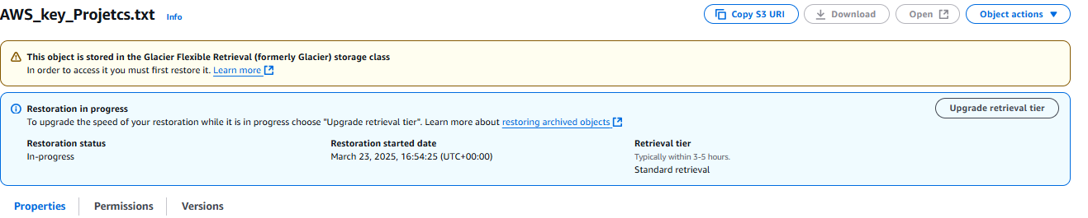

- Verify restore has completed

* Now you can verify that your object has been restored. After waiting about 3-5 hours for the restore operation to complete, go ahead and log back into your S3 console. Select the file name of the object you have attempted to restore to see its current status.

* Here you can see that the object’s Restore status is listed as Completed. The Restoration expiry date, which is based on the number of days we defined in the restore process, is listed as well. You have successfully restored your archived object. This object will be available until the time specified in the Restoration expiry date section. You can now perform actions like run S3 select queries against this file, copy the object to another bucket in your account or to another account, or download the data to your local machine.

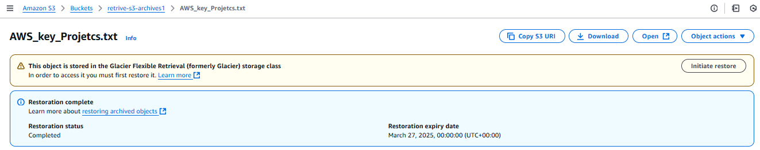

**Task4: Cleanup**

• In the following steps, you clean up the resources you created in this project. It is a best practice to delete resources that you are no longer using so that you do not incur unintended charges.

**Delete test object**

* Navigate to the S3 console and select the Buckets menu option. First you will need to delete the test object from your bucket. Select the name of the bucket you have been working with for this project. Put a check mark in the checkbox to the left of your test object name, then select the Delete button. On the Delete objects page, verify that you have selected the proper object to delete and type “permanently delete” into the Permanently delete objects confirmation box. Then, select the Delete object button to continue. Next, you will be presented with a banner indicating if the deletion has been successful.

**Delete test bucket**

* Finally, you need to delete the test bucket you have created. Return to the list of buckets in your account. Select the radio button to the left of the bucket you created for this project, and then select the Delete button. Review the warning message. If you desire to continue deletion of this bucket, type the bucket name into the Delete bucket confirmation box and select Delete bucket.